LYCEUM OF THE PHILIPPINES UNIVERSITY – LAGUNA
College of Business and Accountancy
SESSION 6 — DIMENSIONAL MODEL DESIGN
Milestone B3 · Grain, facts and dimensions, schema on paper
BDAT04 Fundamentals of Data Warehousing · Saturday 26 September 2026 · Three hours
How this activity works
- Eight items, in three parts. Work them in order — each one uses what the one before it produced.
- Every item has the same two boxes. ANALYSIS is what you found or built. REFLECTION is what it means. Both are marked, and the reflection is worth more than you expect.
- You may use Power BI, your notes, your earlier queries and your feedback letters. Part C is done on paper.
- This activity IS milestone B3. There is no separate submission.
A reflection is not a summary.
Do not tell me what you did — the analysis box already says that. Tell me what it cost, what it would have broken, or what you now see that you did not see before. Two or three honest sentences beat a paragraph of restatement.
Dataset: Kape Tayo, as it stands in your own Power BI workspace. Nothing new is issued today.

PART A — GRAIN
Grain is the single sentence that says what one row of a fact table means. It is the first thing a designer declares and the most expensive thing to get wrong.
ITEM 1 · What is one row of tblSales?
about 20 minutes
What to do
- Load tblSales. Count the total rows.
- Count the DISTINCT values of SaleID.
- Compare the two numbers. If they are equal, each SaleID appears once. If they differ, some appear more than once.
- Look at three actual rows. What does each one describe — a whole sale? a single product within a sale? a day of sales?
ANALYSIS
State the grain in ONE sentence, beginning exactly: “One row of tblSales is …” Then give the two counts you used.
One row of tblSales have the complete data that includes the date of the purchase, where branch did the sales came from, what type of product, how many is a single transaction, how much is the transaction, etc… The total counts of tblSales is 10,589 and have a distinct value of 23, now having a total of 10,566 counts of tblSales excluding the distinct values.

REFLECTION
If your grain sentence is wrong, every number built on this table is wrong and nothing warns you. Which of the two counts would have exposed the error — and what would you have concluded if you had only looked at the rows?
The count of the distinct value is the one who would’ve exposed the error or problem having this result shown lead us to multiple distinct values a total of 23. I would’ve concluded that the whole rows of data in tblSales is perfect and good considering that it looks complete and everyone would easily miss the part where to look from to see the error.

ITEM 2 · What is one row of tblInventory?
about 20 minutes
What to do
- Load tblInventory. Count the rows.
- List the distinct values of MovementType and count the rows in each.
- Decide what a single row records. Is it a stock level, or a stock movement? Those are not the same thing.
- Check whether any column could serve as a unique identifier for the row.
ANALYSIS
State the grain in ONE sentence, beginning “One row of tblInventory is …” List the MovementType values with their counts.
One row of tblInventory has a complete data set that will tell you the movement ID, the date it’s been moved, the branch where it’s going, what product and type of movement. There is a total of 1,541 rows, 23 adjustments 1,451 Delivery, 19 Transfer out, 23 Wastages and 25 (deliveries) this last type is also the same as the Delivery, it became a different values only cause of the formatting of the text.This table is considered as a stock movement because it only contains the number of the product that been moved.

REFLECTION
tblSales and tblInventory are both fact tables, and their grains are different. Write one sentence explaining why you cannot put them in the same table, even though both are about products at branches over time.
I will not put this two type of table in the same one mainly because it contains very different type of data the sales only focuses on the sales movement and unlike the inventory table this only focuses on the movement of the products.

ITEM 3 · The grain test
about 25 minutes
What to do
- Take this business question: “How much revenue did each branch earn in March 2026?” Using only your declared grain for tblSales, decide whether the table can answer it. Show the grouping you would use.
- Now take this one: “What was the average number of items per customer visit?” Decide whether your declared grain can answer it.
- Do not build the answer. Decide whether the grain permits it, and show why.
ANALYSIS
For each question: ANSWERABLE or NOT ANSWERABLE, and the one-line reason that follows from your grain statement.
It’s not answerable by the grain that I made in Sales table, it doesn’t include the data that you are finding so I can’t answer it

REFLECTION
One of these two questions is blocked by the grain, not by missing data. Explain the difference between “we do not have that data” and “the grain of this table cannot express that” — and say which one a business user would find harder to accept.
It’s easier for the first one that we do not have that data because we can easily still get it in the tables, but for the second one is that the grain cannot express it meaning that it cannot explain or reach that type of question or info that you may need _

PART B — FACTS AND DIMENSIONS
A fact table holds the things you measure. A dimension table holds the things you slice by. Most modelling errors are really classification errors made early and never revisited.
ITEM 4 · Classify every column in tblSales
about 25 minutes
What to do
- List every column in tblSales.
- Put each one into exactly one of three buckets: MEASURE (something you would sum or average), KEY (something that points at another table), DESCRIPTIVE ATTRIBUTE (something you would filter or group by, but never sum).
- Two columns will be arguable. Decide anyway, and mark them with an asterisk.
ANALYSIS
A three-column table: Column | Bucket | Why. Every column in the table must appear exactly once.
SalesID* (DESCRIPTIVE ATTRIBUTE), Date (DESCRIPTIVE ATTRIBUTE), (BranchID, ProductID, CustomerID KEY), (Quantity, UnitPrice*, Amount (MEASURE), PaymentMethod(DESCRIPTIVE ATTRIBUTE).
________________________________________________________________________________________________
________________________________________________________________________________________________
REFLECTION
Find a column you could technically sum but never should. Name it and say what the sum would mean — and why producing that number would mislead a reader.
One column that you could sum is the UnitPrice. You could only see the unitprice total in this column and it might cause a misleading information specially its also a number, what I would rather sum is the amount cause this can show us the total revenue and it would show us it’s actual value each transaction.

ITEM 5 · Classify the seven tables
about 25 minutes
What to do
- List the seven Kape Tayo tables.
- Classify each as FACT, DIMENSION, or NEITHER.
- For each FACT, write its grain in one line (you already have two of them).
- For each DIMENSION, name the column that joins it to a fact table.
ANALYSIS
A four-column table: Table | Fact / Dimension / Neither | Grain (facts only) | Join key (dimensions only).
tblSales, tblInventory ( FACTS), tblCustomer, tblProduct, tblBranches, tblEmployee, tblCalendar ( DIMENSION)
for the grain of tblSales it show us the whole transaction or sales for the tblInventory it shows us the whole movement of the products and goods in every branches. For each dimensions the customer is the customer ID, product is product ID, branches is branches ID, employee is employee ID, and the calendar is the date. This is the columns that joins it to the fact table.

REFLECTION
Name the table you found hardest to classify and say what made it hard. A hard case is not a failure — it usually means the business itself has not decided something.
The table I find hardest to classify is the Inventory table, because its hard to determine whether if it’s a stock movement or level.

ITEM 6 · The hard case — tblEmployees
about 20 minutes
What to do
- Open tblEmployees. Read its columns.
- Ask: which fact table has a column that points at an employee? Check tblSales and tblInventory.
- Decide: is tblEmployees a dimension in THIS model, or is it a table that belongs to a different model entirely?
- If it is a dimension, name the fact table it would serve and the key it would use. If it is not, say what it would take to make it one.
ANALYSIS
Your decision, in writing, with the evidence you checked.
tblEmployees is a dimension because the fact table contains EmployeeID, which can be used to connect each fact record to an employee. The join key is the EmployeeID.______________________________________________________________
________________________________________________________________________________________________
________________________________________________________________________________________________
REFLECTION
A dimension nobody joins to is not a dimension — it is a table sitting in your file. What would you say to a manager who insists it belongs in the model because “we have the data”?
I would explain to the manager that having the data does not automatically mean it belongs in the model. A dimension needs to have a useful relationship with a fact table. If nothing joins to tblEmployees, its information cannot be used to describe or analyze the facts in this model. The data may still be useful, but it would need a proper relationship before it becomes a meaningful dimension.
__________________________________________________________________
________________________________________________________________________________________________
________________________________________________________________________________________________

PART C — SCHEMA ON PAPER
You draw the schema before you build it, because paper forces you to decide what the software would quietly decide for you.
ITEM 7 · Draw the schema on paper
about 30 minutes
What to do
- On PAPER — not in Power BI — draw your model.
- Put your fact table or tables in the centre. Put the dimensions around them.
- Draw a line for every relationship. Write the key name on each line.
- Mark the SIDE of each relationship: which table is ONE, which is MANY. Use a 1 and a *.
- Label your diagram with your name and photograph it.
ANALYSIS
A photograph of your drawing, inserted below or submitted alongside this sheet.

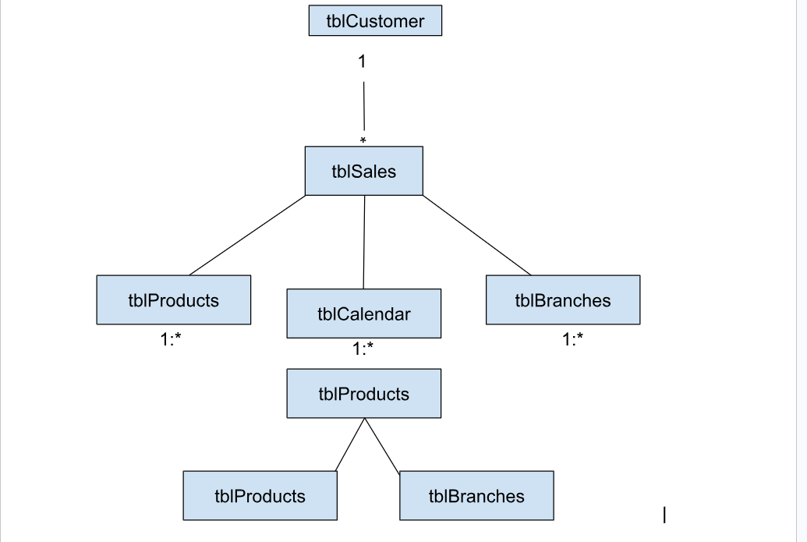

REFLECTION
You drew this before building it. Why does the syllabus ask for paper first? Answer from what happened while you were drawing — something you had to decide on paper that the software would have decided for you.
Doing this helped me decide first on what should be connected, it helped me analyze the tables first and use my skill rather than looking at what the power Bi decides to do.
ITEM 8 · The dimension that serves both
about 15 minutes
What to do
- Look at your drawing. Find the dimension or dimensions that connect to BOTH fact tables.
- Name them.
- Now imagine you had built two separate copies — one for Sales, one for Inventory.
ANALYSIS
The name of the shared dimension, and the two fact tables it serves.
The tblCalendar have the shared dimensions and the two fact table it serves is the tblSales and the tblInventory because these two tables have the data to analyze the sales and inventory by the given date data.
REFLECTION
Describe one specific report that would go wrong if Sales and Inventory each had their own private copy of that dimension. Be concrete: name the report, and say what number would be wrong.
The one specific report that would make the sales and inventory wrong is if they have their own dates and time that they are using this would lead to confusion and would make an inconsistent report. That’s why having a shared date calendar is better

B3 — FORMAL SUBMISSION BLOCK
Copy your final answers here. This is the page marked against the syllabus milestone. Everything in it should already exist somewhere in Items 1 to 8 — if it does not, go back.
1 · Grain statement, one per fact table
Written as a full sentence. “One row of … is …”
One row of tblInventory represents one inventory movement, such as a delivery, adjustment, transfer, or wastage.
One row of tblSales represents one sales transaction.___________________________________________________________________
________________________________________________________________________________________________
________________________________________________________________________________________________
2 · Fact tables, with their measures
tblSales (Quantity,UnitPrice,Amount)
tblInventory (QuantityMoved)____________________________________________________________________
________________________________________________________________________________________________
________________________________________________________________________________________________
3 · Dimension tables, with the key each one joins on
tblCustomer-CustomerID
tblProducts-ProductID
tblBranches-BranchID
tblCalendar-Date
tblEmployees_EmployeeID
4 · Relationships — one line each, in the form DIMENSION 1 — * FACT (key)
tblCustomer 1-*tblSales (Customer ID)
tblProducts 1-*ProductID (ProductID)
tblBranches 1-*BranchID (BranchID)
tblCalendar 1-*tblSales(Date)
tblProduct 1-*tblInventory(Product ID)
tblBranches 1-* tblInventory(branch id)
tblCaledanr 1 -* tblnventory(Date)

5 · One design decision you are not certain about, and what you would need to resolve it
I am not completely certain whether tblEmployees should be included as a dimension in this model. I would need to confirm whether EmployeeID exists in either fact table and whether it represents the employee responsible for the transaction or inventory movement. If there is no valid relationship, tblEmployees may belong to a different model or require additional data before it can be used as a dimension.
Schema drawing attached / photographed: YES · NO Name: ______________________________

How this is marked
Criterion | Weight
Grain statements are correct, complete and written as sentences | 25
Facts, dimensions and keys classified correctly, with the hard cases defended | 25
Schema drawing — complete, keyed, sides marked | 20
Reflections — honest, specific, and about consequence rather than restatement | 25
Submitted complete and on time | 5
An item with a correct analysis and an empty or restating reflection earns roughly half of what it could. That is deliberate. The analysis shows you can operate the tool; the reflection shows you understand what you just did.
— Sir JB

